SQL VIEWS

A view is a query that is stored in the database. It behaves very much like a virtual table that was created by selecting rows and columns from other tables. In most situations it can be used just like an actual table. There is no real overhead with creating a view, as there is no actual data stored in the view. It is created by select statement(s) and the data remains in the original tables.

Some common uses for SQL views are:
- simplifying data retrieval from complex queries
- hiding the underlying table structure
- controlling access to data for different users

SIMPLIFYING DATA RETRIEVAL
As you may be starting to notice, sometimes we need to code complicated select statements containing joins, aggregates, function, unions, etc. to produce the results we want. A view can simplify this task. Some or all of a complex select statement can be created as a view and future queries of that information can be executed against the view.

For example, if we were often executing queries involving publishers and their titles we would constantly be writing selects with a join to retrieve data from those tables and then executing additional criteria in the where clause to retrieve more specific data. A view could be created which returns all the publishers and their titles. Any specific queries about that data could then be executed against the view. This would allow us to not have to code a join condition every time we wanted information from those tables together as we have already created a view that contains that information.

HIDING THE UNDERLYING TABLE STRUCTURE
By creating a view we create an additional layer between the user and the tables. If the definition of a table changes only the view needs to be altered to accommodate the changes. As long as the view contains the same data as it did before the changes to the underlying table(s) then the user is unaware of the changes and they are of no concern to them.

A common example of this is when a table gets too big and some of the records are moved to an archive table. If a view was being used that contained all the rows and records of the original table it could now be altered to select all the records from the original table and UNION them with the records from the archive table. As far as the user of the view is concerned the view contains the same records as before. The definition of the view had to be changed to select the records from both the original table and the archive table, but the end result is the same. The view contains all the records that were there originally.
CONTROLLING ACCESS TO DATA
By creating a view you can restrict which columns certain users are able to see. Suppose that some information in an employee table should be available to everyone but some columns are restricted information. A view can be created that contains the columns that are available to everyone and permissions can be granted on that view to everyone. Other views could contain other combinations of columns and permissions could be granted accordingly to those views for the appropriate users and groups.

DATA MODIFICATION
A user can do more than just select data from views. As mentioned before a view can be treated like a table (with a few exceptions). You can update, insert, and delete records in a view just as if you were doing so on an actual table. Any changes to the view are reflected in the records in the table(s) that make up the view.

Here are some points to keep in mind when modifying records through a view:
- Modifying records through a view must meet all rules and constraints that were created on the table(s) that the view is based on
- An insert or an update from a view that is using more than one table cannot affect more than one table in the view
- You cannot delete from a view that is based on more than one table
- If the SELECT statement contains group by, distinct, top, or union you cannot modify data in that view

CREATING A VIEW
SYNTAX:

CREATE VIEW viewname
AS
Select …

NOTE:
- the CREATE VIEW command must be the first statement in a batch or can be executed as a separate statement
- a view cannot reference more than 1024 columns
- a view must be created in the current database; however, it can reference tables in other databases

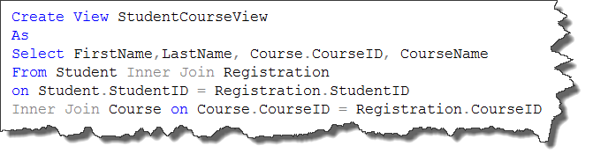
What can we do with this view?

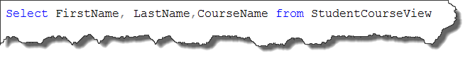
Works!

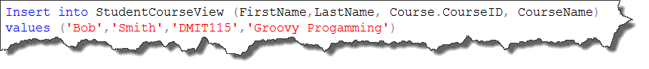

Fails. You cannot insert data through a view if the view is based off of multiple tables.
View or function 'StudentCourseView' is not updatable because the modification affects multiple base tables.

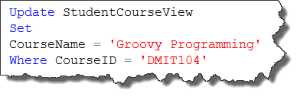
Works. You can update through a view but only if you are updating one table in the view.

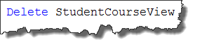
Fails. You cannot Delete through a view if the view is based on more than one table.

ALTERING OR DROPPING VIEWS

Views can be altered and dropped using the same syntax as stored procedures with the ALTER and DROP keywords.

SYNTAX:

ALTER VIEW viewname
AS
Select …

SYNTAX
DROP VIEW viewname

RETRIEVING THE VIEW DEFINITION

Since the view is stored in the database you can retrieve the code that created it.

SYNTAX:

SP_HELPTEXT viewname

